Lab manual – Login to Windows EC2 instance

Open the Remote Desktop connection application
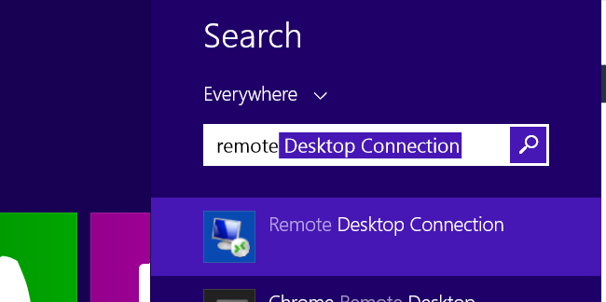

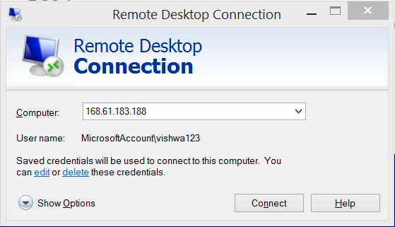
Enter the “ipaddress”

For windows machine, we cannot use the “private key” that was generated in the AWS for login to instance.
So , we hve to convert the private key to normal password.
Click on ‘Connect’
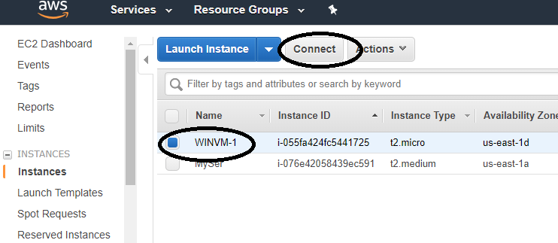
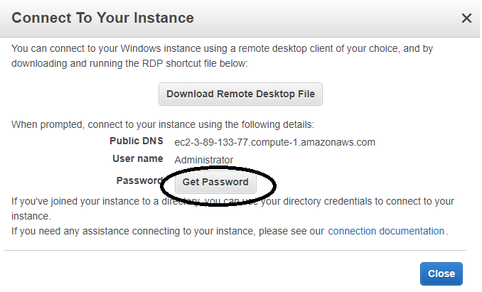
Click on “Get password”
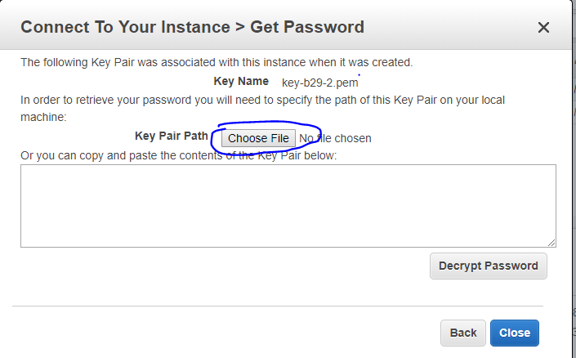
Click on “Choose file” and select the “.pem” private key that is downloaded.
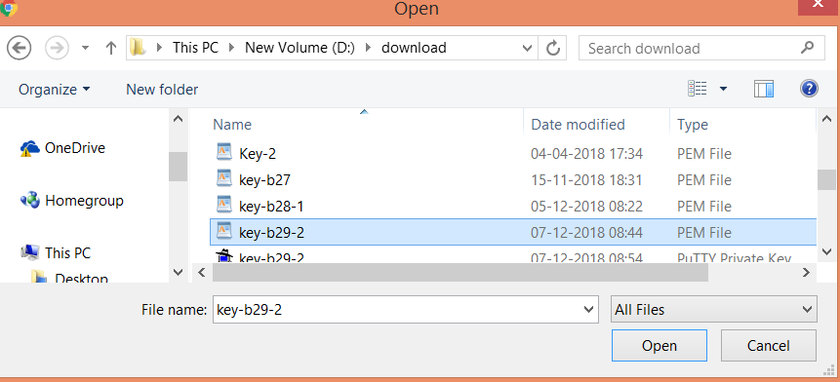
And Click on “ok”
Now click on “Decrypt password”
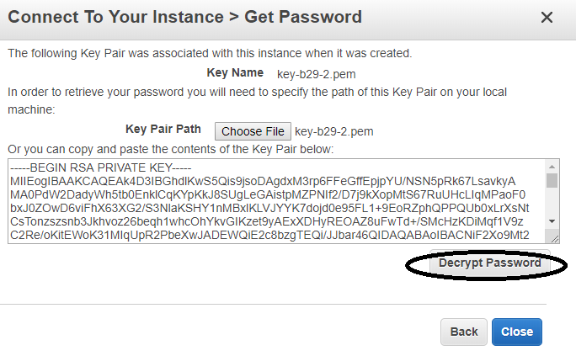
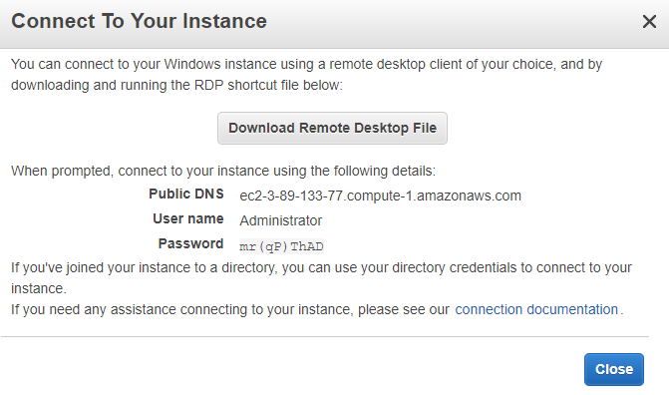
The username and password would be the details for your windows EC2 instance.
And you should be able to login via that for future logins as well.

Go back to your remote desktop connection application.
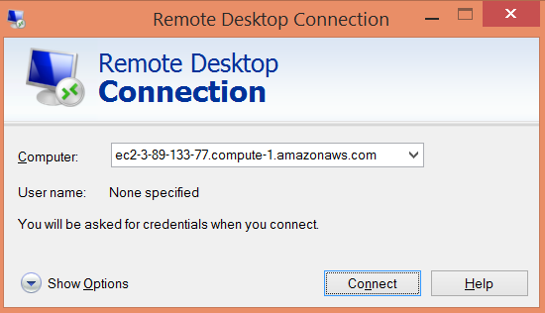
Click on “Connect”.
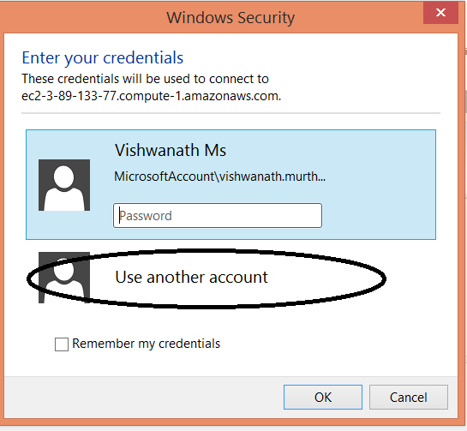
Click on “use Another account”.
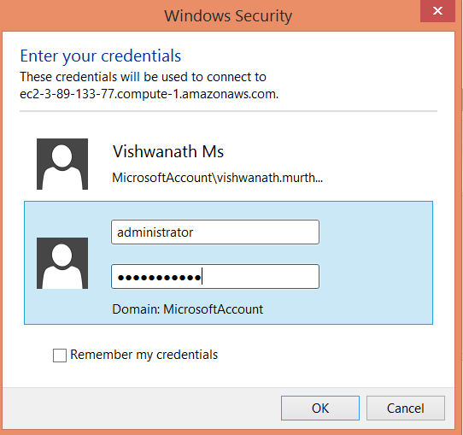
Click on “OK”.
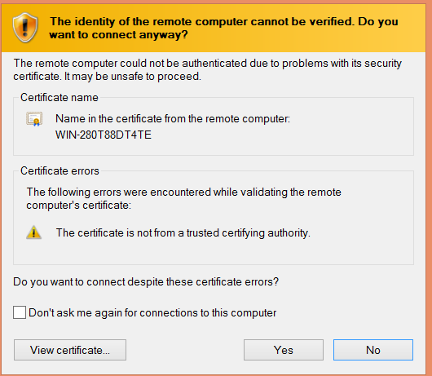
Click “Ok” on this screen to verify the connection.
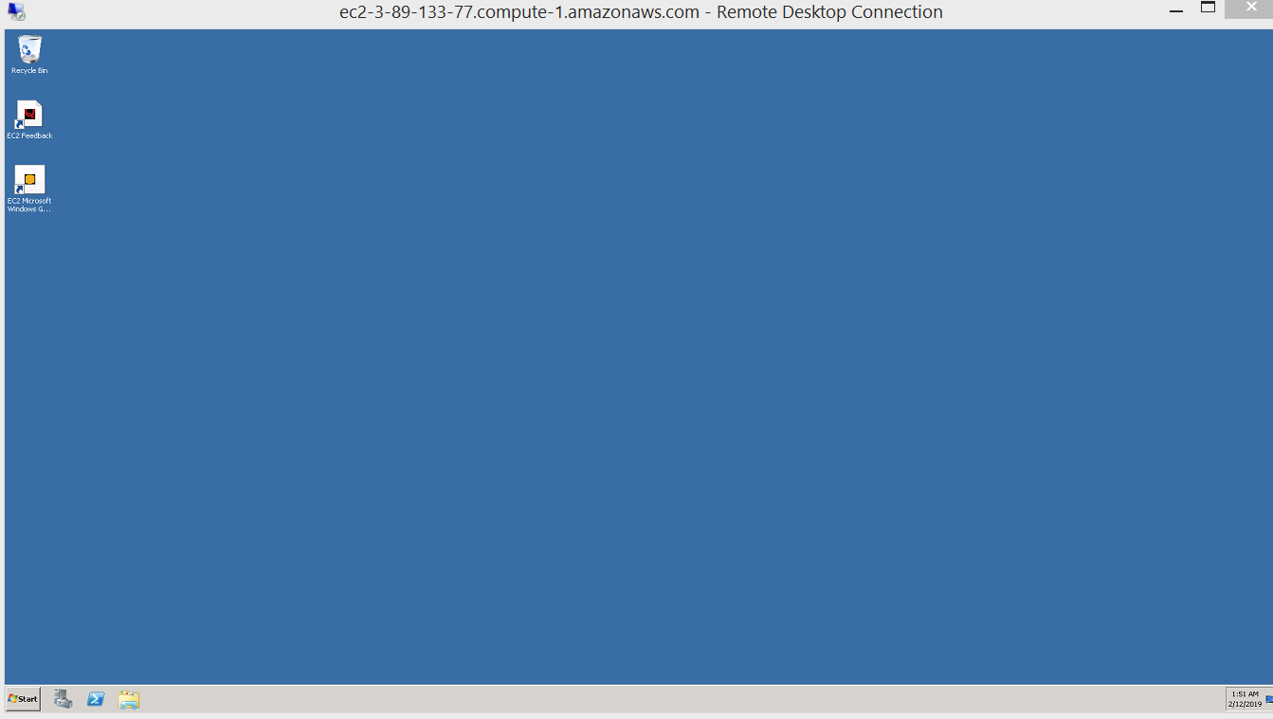
This should be the remote desktop connection of the Windows EC2 instance.

